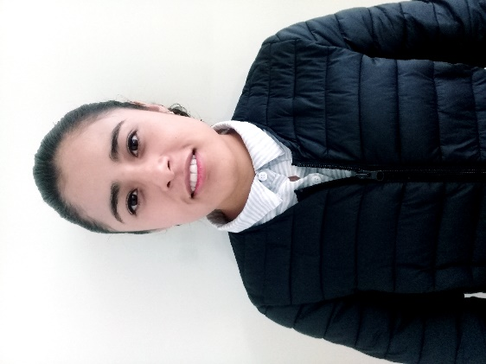**FRIDA SOFIA BERMÚDEZ SÁNCHEZ**

September ${17}^{th}$, 1997 20 years

BESF970917MMNRNR02

Hidalgo Street, Sout #46 Contepec, Michoacán. C.P 61020 447-108-08-07

Sofiber17@gmail.com Single Mexican

Objectives

Give a know new innovative ideas in the enterprise, employing the knowings acquired throughout my academic preparation to contribute with the growing and achievement of objectives for same.

Education

UTL CAMPUS ACÁMBARO

***2017***| TSU in Information and Communication Technologies.

* Título en Económico Administrativo con bachillerato en Físico-Matemático y Químico-Biológico.

Work Experience

Sales Manager since jULY ***2016 to the date.***

Telcel Distribuidor Autorizado | Contecel.com

High and activation of cell phones. Realization of air time recharge. Unlocking Android mobile devices. Sale of accessories for cell phones. Realization of inventory, registration, discharge, and consultation of same.

Development of Advertising Website for the company "Mi Casa" and "ECOINN".

Languages

* **English** Medium level.

Skills And Knowledge

* Job in team, facility of word, sleigh for sociology with the people and experience in sales. Availability for learn to manipulate various tools, and I consider myself a perfectionist person. I am very creative for design.
* Manipulate parcel of Office 2010, 2013, 2016.
* Desing editors: Corel Draw, Photoshop medium level, Adobe Firework. Audio and video editors: Sound Forge, Camtasia, Adobe PremierePro, Adobe Edge. 3D Desing: Blender y MakeHuman.
* CMS: Wordpress. Knowing in programation languages: java, php, javascript.
* Software of programation: NetBeans, Sublime, Brackets.

References

* **Jhoana Elizabeth**

417-589-56-96 Vicente Guerreo Street #30, Acámbaro.

* **Miguel Ángel Ríos Gómez**

447-125-85-32 Nicolás Bravo Street #27, Maravatío, Mich.